cnc_pdf_searchresult

声明
/* line edit (search string) */
[DllImport("FWLIB32.dll", EntryPoint="cnc_pdf_searchresult")]
public static extern short cnc_pdf_searchresult( ushort FlibHndl, out uint a );

描述
搜索程序字符。
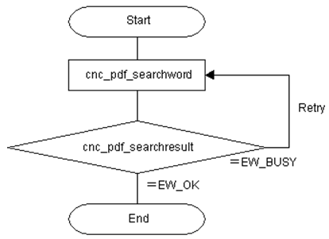

参数
（1）FlibHndl 库句柄；[ in ]
（2）serach_no [ out ]

函数返回值
函数运行正常返回EW_OK。
Return code | Meaning/Error handling
EW_BUSY  (-1) | Busy  CNC is searching the program text right now.
EW_FUNC  (1) | No execution on searching the string. (cnc_pdf_searchword)
EW_DATA  (5) | Data error  Specified string cannot be found.
EW_NOOPT  (6) | No option  The extended driver/library function is necessary.
EW_NUMBER  (3) | The line starting number search error

代码
class Program
{
static void Main(string[] args)
{
ushort Flibhndl = 0;

short ret; // 返回值

// 获取库句柄 ( Ethernet )
ret = Focas1.cnc_allclibhndl3("192.168.0.224", 8193, 10, out Flibhndl);
if (ret != Focas1.EW_OK)
{
Console.WriteLine("发生异常，请检查！");
return;
}

#region cnc_pdf_searchword & cnc_pdf_searchresult

short serach_no=0;

string prog_name = "//CNC_MEM/USER/PATH1/O0888";
uint line_no=0;
uint type = 0;
uint direct = 0;
uint repeat = 100;
string prog_data = "M06";
do
{
ret = Focas1.cnc_pdf_searchword(Flibhndl, prog_name, line_no, type, direct, repeat, prog_data);
ret = Focas1.cnc_pdf_searchresult(Flibhndl, out serach_no);
}
while (serach_no == -1);

#endregion
}
}

